Posted 11.15.2010 at 1:50 pm by JAV

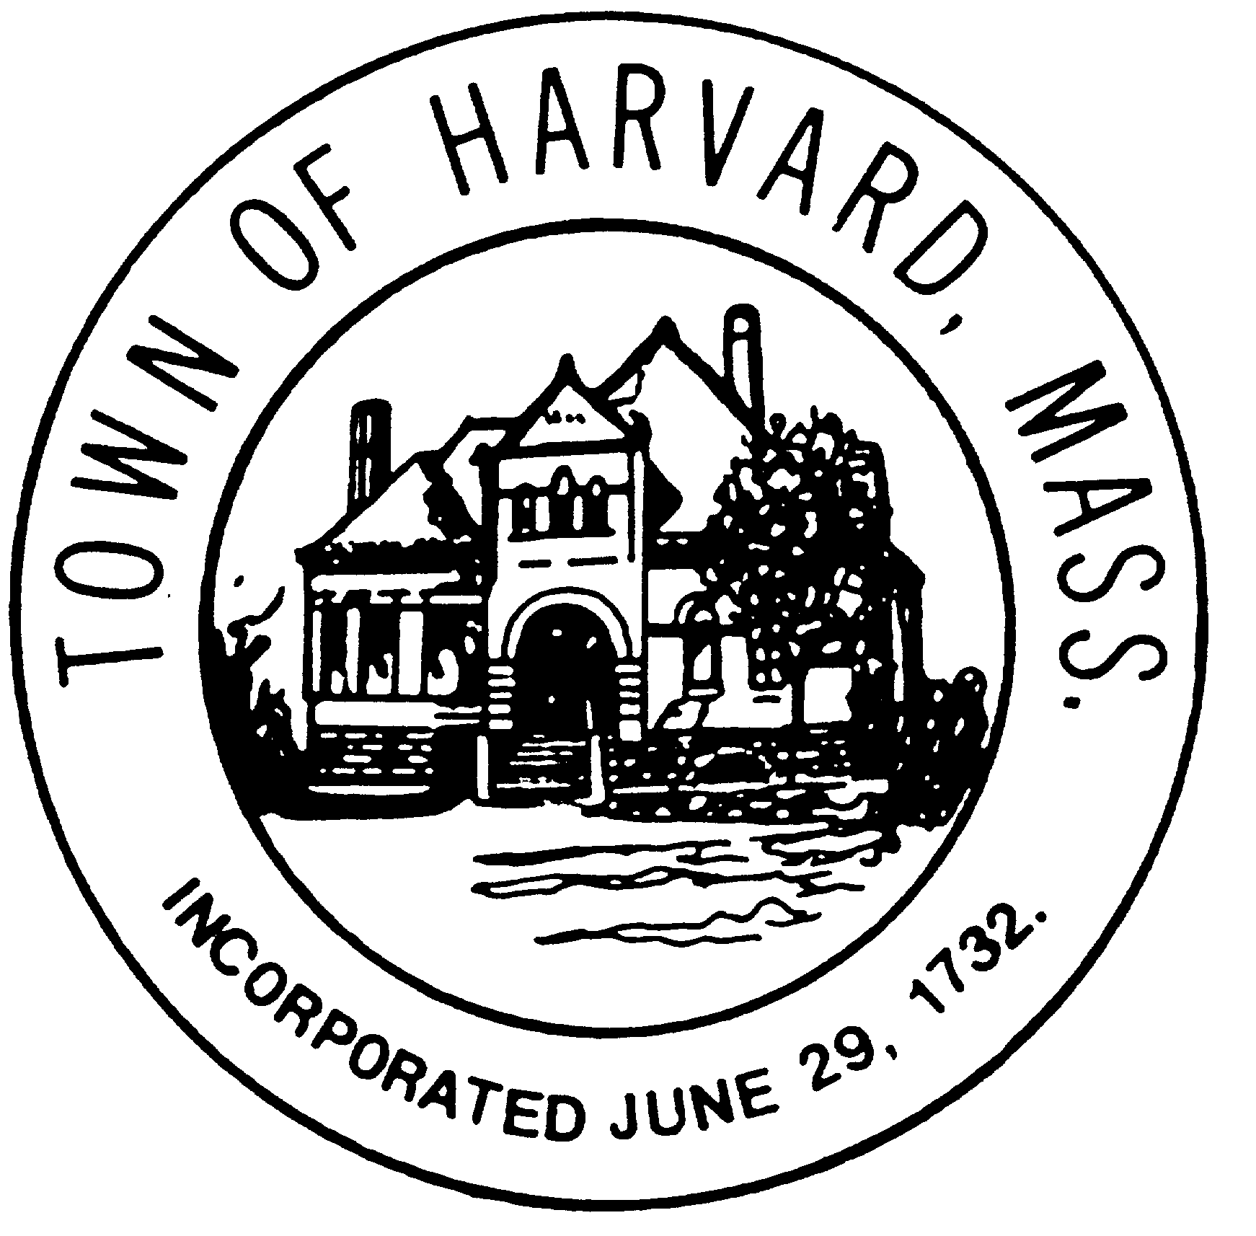
Board: Municipal Buildings Committee AGENDA

Day & Date: Thursday, November 18, 2010
Time: 9:30 – 11:15 am
Location: Town Hall meeting room

- Reading and approval of minutes of November 4 meeting
- Review of Workshop #2
  - Town Hall – comments and preferences (Marie and Doug)
  - Old Library – comments and preferences (Maggie and Willie)
  - Council on Aging (old library and Hildreth) – comments and preferences (Lucy)
- Next Steps
  - Design Team – schedule for the following: (Doug and Maggie)
    - Modification/completion of architectural and civil drawings for estimating
    - Architectural narratives required for estimating
    - Engineering narratives required for estimating
    - Cost estimating
  - Cost/Benefit Analysis (Ron)
    - Ranking by Benefit to the Town
    - Ranking by Cost to the Town
    - Composite ranking
  - Implementation strategy (Ron)
    - Ingredients
    - Schedule
  - Additional work – (N.B. Personnel required)
    - Space utilization study (characterization of other spaces)
    - Commercial real estate analysis
      - Hildreth – whole; two parcels; one parcel; rezoning
      - Old Library – ‘comps’
    - Financing
      - Public/Private Partnerships – structure and financing
      - Public Funding
        - State and Federal Grants
        - CPC
        - Tax Credits
        - Bonding (Marie)
      - Private Funding
        - Philanthropy
        - Grants
    - Program for Public Education (Maggie)
      - Historic role of the three buildings – our patrimony
      - Program descriptions
- Next Workshop – notices; promotion; scope

